**ASSIGNMENT -1**

Er.Perumal Manimekalai College of

Engineering,Hosur.

**NAME** : KAILASH U

**CLASS** : 3 YEAR ECE

**SUBJECT** : IBM

**REGISTER NO** : 610820106025

**RFID Lock System With Servo Using Arduino**

**DESIGN PART**

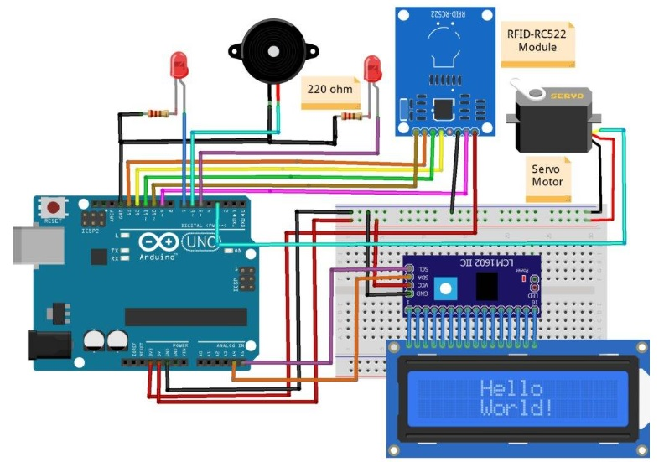

**CODING PART**

**#include <SPI.h>**

**#include <MFRC522.h>**

**#include <Servo.h>**

**#include <Wire.h>**

**#include <LiquidCrystal_I2C.h>**

**LiquidCrystal_I2C lcd(0x3F,16,2);**

**Servo s1;**

**#define SS_PIN 10**

**#define RST_PIN 9**

**#define LED_G 5 //define green LED pin**

**#define LED_R 7 //define red LED**

**#define BUZZER 6 //buzzer pin**

**MFRC522 mfrc522(SS_PIN, RST_PIN); // Create MFRC522 instance.**

**//Servo myServo; //define servo name**

**void setup()**

**{**

**Serial.begin(9600); // Initiate a serial communication**

**SPI.begin(); // Initiate SPI bus**

**lcd.init();**

**lcd.backlight();**

**;**

**mfrc522.PCD_Init(); // Initiate MFRC522**

**s1.attach(3); //servo pin**

**// myServo.write(0); //servo start position**

**pinMode(LED_G, OUTPUT);**

**pinMode(LED_R, OUTPUT);**

**pinMode(BUZZER, OUTPUT);**

**noTone(BUZZER);**

**Serial.println("Put your card to the reader...");**

**Serial.println();**

**lcd.setCursor(0,0);**

**lcd.print(" Put your card ");**

**}**

**void loop()**

**{**

**// Look for new cards**

**if ( ! mfrc522.PICC_IsNewCardPresent())**

**{**

**return;**

**}**

**// Select one of the cards**

**if ( ! mfrc522.PICC_ReadCardSerial())**

**{**

**return;**

**}**

**//Show UID on serial monitor**

**Serial.print("UID tag :");**

**String content= "";**

**byte letter;**

**for (byte i = 0; i < mfrc522.uid.size; i++)**

**{**

**Serial.print(mfrc522.uid.uidByte[i] < 0x10 ? " 0" : " ");**

**Serial.print(mfrc522.uid.uidByte[i], HEX);**

**content.concat(String(mfrc522.uid.uidByte[i] < 0x10 ? " 0" : " "));**

**content.concat(String(mfrc522.uid.uidByte[i], HEX));**

**}**

**Serial.println();**

**Serial.print("Message : ");**

**content.toUpperCase();**

**if (content.substring(1) == "5B 2F 4B 0C") //change here the UID of the card/cards that you want to give access**

**{**

**Serial.println("Authorized access");**

**Serial.println();**

**lcd.setCursor(0,0);**

**lcd.print(" CARD IS VALID ");**

**lcd.setCursor(0,1);**

**lcd.print("Opening the Door ");**

**digitalWrite(LED_G, HIGH); //Green LED ON**

**s1.write(0);**

**delay(3000);**

**s1.write(90);**

**lcd.setCursor(0,1);**

**lcd.print("closing the Door ");**

**digitalWrite(LED_G, LOW); //Green LED OFF**

**delay(2000);**

**lcd.setCursor(0,0);**

**lcd.print(" Put your card ");**

**lcd.setCursor(0,1);**

**lcd.print(" ");**

**}**

**else**

**{**

**Serial.println("CARD IS INVALID");**

**lcd.setCursor(0,1);**

**lcd.print("CARD IS INVALID ");**

**digitalWrite(LED_R, HIGH); // Red LED ON**

**tone(BUZZER, 300); // Buzzer ON**

**delay(2000);**

**digitalWrite(LED_R, LOW);**

**noTone(BUZZER);**

**lcd.setCursor(0,1);**

**lcd.print(" ");**

**}**

**}**